



FPT UNDEFINED FLYING OBJECT
System Requirement Specification

Project Code: FUFO
Document Code: FUFO v1.0

Ha Noi, 1st May 2012
Record of change

*A - Added M - Modified D - Deleted
Effective Date | Changed Items | A*  M, D | Change Description | New Version
04-May-2012 | Detail purpose and scope. | A* | Create newly specification | V 0.1
09-May-2012 | Functional VP | A* | Create functional VP | V 0.2
22-May-2012 | Product functions | M | Describe more detail product function | V 0.3
2-June -2012 | System features | M | Describe feature of Quadrocopter | V 0.9
3-June-2012 | External Interface | M | Modify user interface of AOC | V 1.0

SIGNATURE PAGE

ORIGINATOR: TRAN THI YEN 19-May-2012
Member

REVIEWERS: VU MINH PHONG 20-May-2012
Project Manager
LY KHOI NGUYEN 20-May-2012
Member
VU DUC THANG 20-May-2012
Member

APPROVAL: PHAN DUY HUNG 22-May-2012
Introductor

Table of Contents
1 Introduction 5
1.1 Purpose 5
1.2 Scope 5
1.3 Definitions, Acronyms, and Abbreviations 6
1.4 References 7
2 Overall Description 8
2.1 Product perspective 8
2.2 Product functions 8
2.3 User characteristics 9
2.4 Operating Environment 10
2.5 Constraints 10
2.6 Assumptions and dependencies 10
3 System Features 11
3.1 AOC- Application on Computer 11
3.2 AOP- Application on Phone 11
3.2.1 Description and Priority 11
3.2.2 Functional Requirements 11
3.3 FUFO- A Quadrocopter 11
4 External Interface Requirements 12
4.1 User Interfaces 12
4.1.1 User Interface on circuit board 12
4.1.2 User Interface on computer 12
4.1.3 User Interface on smart phone 13
4.2 Hardware Interfaces 15
4.2.1 Hardware Interface on Quadrocopter Circuit 15
4.2.2 Hardware interface on Mobile phone 16
4.3 Software Interfaces 16
5 Supporting Information 17

Introduction
The FUFO project develops commercialized a Quadrocopter. This is a large project which may needs four phase, each phase will be a relevant project which lead to the final product. This phase just focuses on the first: Evaluation phase.
This document describe the requirement specifications of a Quadrocopter system that use Bluetooth and Internet Protocol to communicate. After the development of this phase, functions that might meet specific customer requirements will be evaluated

Purpose
This SRS document fully describes external behavior of the application. It includes two main parts:
- Overall description includes the following items: product perspectives, product functions, user characteristics, constraints, assumption and dependencies. This part provides background information to make the requirements be easier to understand.
- The requirement specification phase provides detailed information about FUFO system. That means the software and hardware requirement of this system will be covered completely. Hence, it would provides the most important information for project manager, designer, tester and maintainer

Scope
This project phase focuses on:
- Making a simple Quadrocopter.
- Using Bluetooth an Internet protocol to communicate.
- Evaluating the application of Android Phone & PC in controlling UAV.
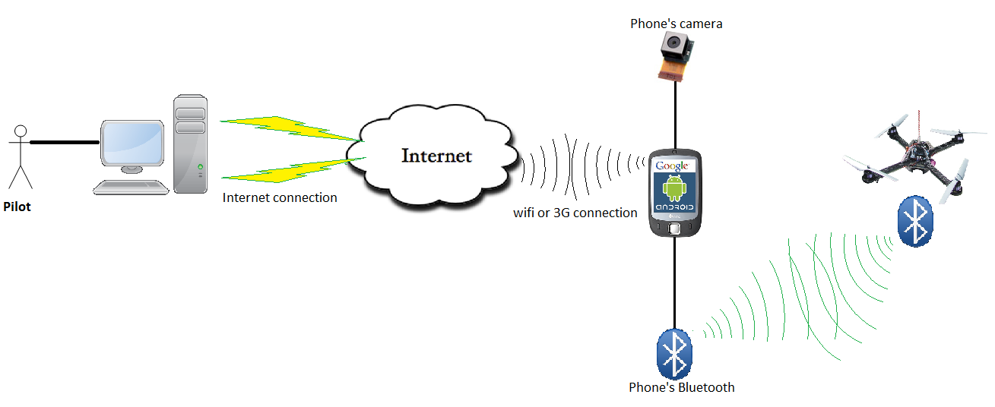

Definitions, Acronyms, and Abbreviations
Acronym | Definition | Note
PM | Project Manager
PTL | Project Technical Leader
TL | Team Leader
QA | Quality Assurance Officer
DV | Developer
SRS | Software Requirement Specification
ADD | Architecture Design Document
DDD | Detail Design Document
TP | Test Plan
TC | Test Case
SC | Source Code
AOP | Application on phone
AOC | Application on computer
FUFO | FPT University Flying Object | Controlled by AOC through AOP
PC | Personal Computer | Refer to any PC or laptop today

References
Document | Source | Note
Template Software Requirements Specification | FPT Software
Information from website: | http://www.microchip.com/

Overall Description

Product perspective
This FUFO system is the result of the evaluation phase of a bigger FUFO project, whose result is a Quadrocopter system that usable in security and observation purposes. The big FUFO project may need 3.5 years to finish, but this evaluation phase is only last for 4 months.
Other results of this project are two study reports on the ability to hover of Quadrocopter and real-time video streaming over Internet.

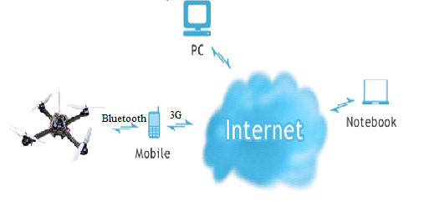
Figure 2.1 Product Perspective

Product functions
The aim of this phase is to make a basic Quadrocopter system that has ability to be controlled over Internet and Bluetooth via a Video Stream, as well as automatically balances itself while hovering. However, due to the shortage of time and money, the system will use an Android Smart Phone as an intermediary for video streaming and commanding over Internet
To be specific, the functions of the system is as the following:
- The Quadrocopter:
- Can be controlled via Bluetooth by an Android Smart Phone's application (AOP).
- Can send its sensors status to the Android Smart Phone via Bluetooth.
- Can automatically keep itself balance while hovering.
- Battery system should last at least 15 minutes when the Quadrocopter does not carry any weight.
- Can carry at least 500 grams and hover at least 30 meters high.
- The Android Application:
- Receives control command from PC.
- Sends control command to Quadrocopter.
- Send video and Sensor's status to PC.
- Easy to use, maintain and update.
- The PC Application:
- Receives video and Sensor’s status from Android Smart Phone and display them.
- Sends control command to Android Smart Phone.
- Is easy to use and good looking.
- Is easy to maintain and update.

User characteristics
There are two kind of user for this system, each has a different characteristics:
- The development team:
- Fully understand the system.
- Focuses on finding obstacles and undefined issues of the system to compare them with the advantages.
- Contains all the development team members.
- The evaluation user:
- Partially understand the system.
- Focuses on finding the own experiences and feeling while using FUFO system.
- May be anyone who is interested in the project

Operating Environment
There is more than one meaning for the term "Environment":
- The Nature environment for the Quadrocopter to hover in:
- Both out-door and in-door environment.
- Acceptable humidity.
- Acceptable temperature.
- The Technology environment for the Communication and software of FUFO system:
- Mobile 3G network
- 100 Mbs Wi-Fi network
- Any ADLS network available.
- Android 2.3 or higher.
- Windows XP and above.

Constraints
No | Description | Type
1 | Deliver on time and meet the requirement | Schedule
2 | All member of team must try their best, complete this work on time within 4 months | Staff
3 | Usable with Bluetooth version 2.1 | Product
4 | Product only use an Accelerometer, a Gyrocopter, and a Barometric meter | Hardware
5 | Application on PC can run in many OS using JAVA virtual machine | Product

Assumptions and dependencies
No | Description | Type
1 | Install on Computer ( Laptop or PC) | Infrastructure
2 | Product can connect to Internet and PC. | Infrastructure
3 | Project team members are available as needed to complete project tasks and objectives. | Member

System Features

AOC- Application on Computer
3.1.1 Description and Priority
The software must display the current altitude and the inclination of FUFO frame. Beside, user can control the FUFO by 8 buttons: “right-left”, “frontward-backward”, “up-down”, “left-rotate – right-rotate” and showing real-time video

3.1.2 Functional Requirements
REQ-1: The software can show altitude of FUFO belongs in meters (0~600m)
REQ-2: The inclination belongs in degree (- 90º + 90º)
REQ-3: The control system must meet to keyboard.

AOP- Application on Phone

3.2.1 Description and Priority
The software must record video from camera of smart phone, and receive the following information: current altitude, inclination from FUFO frame.
Beside smart phone can be used a remote control. It includes control system have 8 buttons: “right-left”, “frontward-backward”, “up-down”, “left-rotate”, “ right-rotate” and showing real-time video

3.2.2 Functional Requirements
REQ-1: The software receive and send information of FUFO: the altitude, inclination
REQ-2: The smart phone is intermediary object can create a connection between FUFO frame and PC
REQ-3: Uses remote control

FUFO- A Quadrocopter
3.2.1 Description and Priority
This Quadrocopter is a multicopter lifted and propelled by four motors. The motors are mounted on the same plane, forming a square

3.2.2 Functional Requirements
REQ-1: Quadrocopter must keep balance in the middle of the air
REQ-2: Quadrocopter can maintain a reasonable specified altitude

External Interface Requirements

User Interfaces

4.1.1 User Interface on circuit board
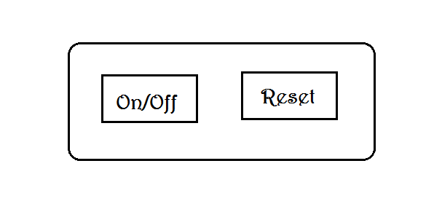
There are two buttons on the circuit board of the Quadrocopter: On/Off an Reset. The formal is to turn on/off the power source whilst the latter is to reset firmware of the circuit.

4.1.2 User Interface on computer
Application on the computer includes:
- Video stream from smart phone which is attached on FUFO frame
- Control interface
- The altitude of FUFO frame compares with the ground
- The inclination of FUFO frame compares with the sea level
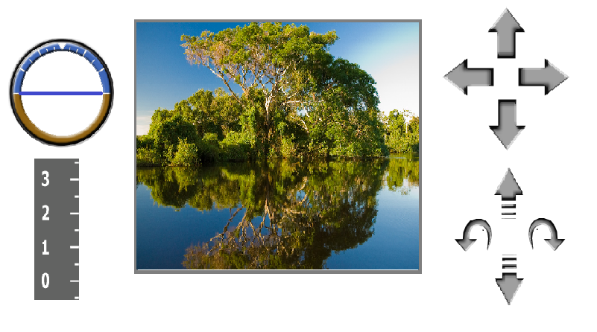

4.1.3 User Interface on smart phone
Application set up on the smart-phone includes 2 tabs: “SETTING” and “CONTROL”.
By choosing tab1 “SETTING”, user can select connection methods: Bluetooth or Internet Protocol.

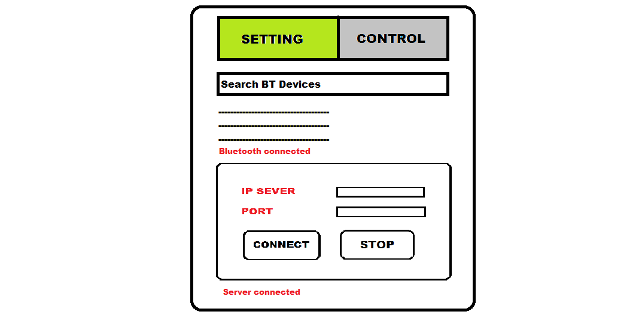
By choosing tab2 “CONTROL”, user can control FUFO by arrows such as “right”, “left”, “frontward”, “backward” and “up”, “down”, “left-rotate”, “and right-rotate”

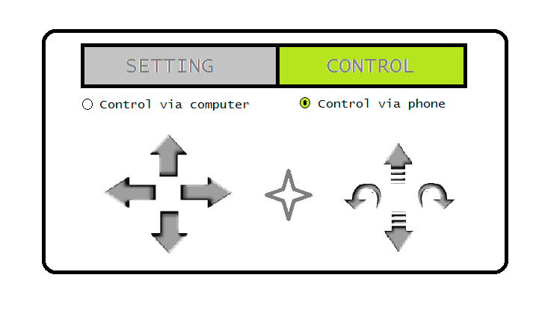

Hardware Interfaces

4.2.1 Hardware Interface on Quadrocopter Circuit
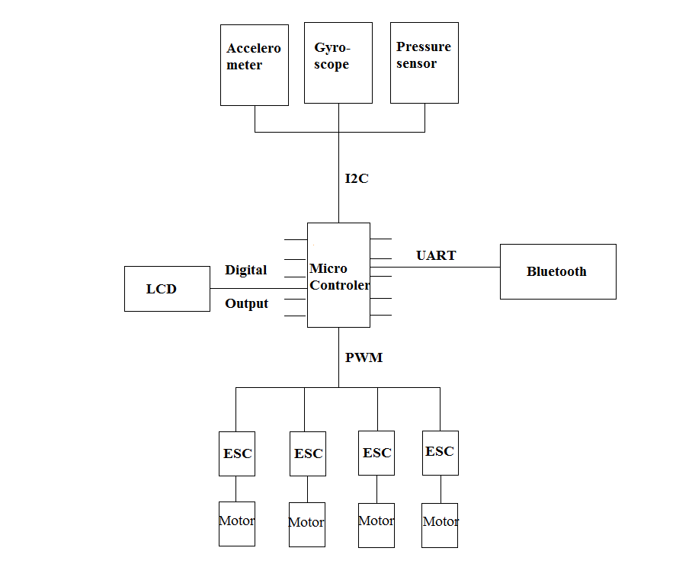

4.2.2 Hardware interface on Mobile phone
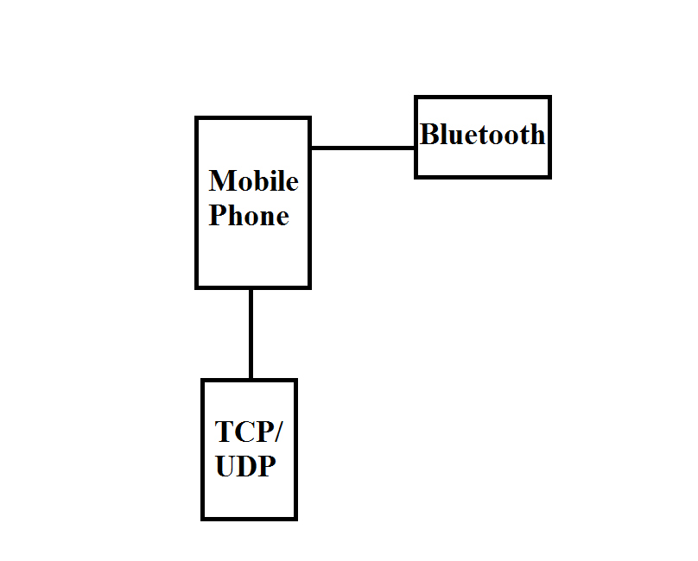

Software Interfaces
In our system, there are three software are used:
- The software on computer (AOC)
- The software on Phone (AOP).
- The Firmware on Quadrocopter.
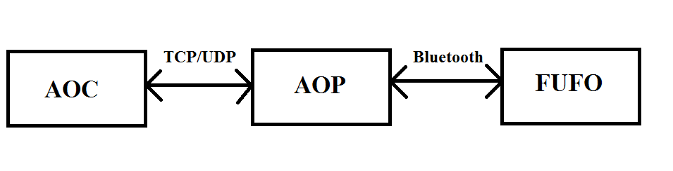

Supporting Information
N/A

